GROUP TWO PROCESS MODELLING REPORT
HEALTHBRIDGE
GROUP MEMBERS
NAME | REGISTRATION NUMBER | ROLES
Tumukunde Isaac | 2024/BCS/162/PS | Documentation Leader
Aryamanya Lucky | 2024/BCS/045/PS | Database Designer
Nambatya Bladina Doreen | 2024/BCS/128/PS | Requirements Analyst
Nanjuki Daphine | 2024/BCS/129/PS | Project manager
Kusingura Jachin | 2024/BCS/091/PS | Project tester
Arinda Leticia | 2024/BCS/043/PS | System designer

Description of the project; A web-based platform that connects community members (especially in underserved areas) to local health resources. It allows users to search for clinics by location, filter by services and medicine availability, view results on an interactive map, and access health education materials. Authorized administrators (NGO and clinic staff) can update and verify clinic information in real time.
Organisations or sector to be use by the project; Non-Governmental Organizations (NGOs), Community Health Centers for example Ruharo Mission Hospital, TASO Mbarara among others and the broader healthcare sector serving low-income and underserved communities for example Good Samaritan Clinic

PROCESS MODELS
These describe how information flows and how activities occur in the system and they include; Context Diagram, Level 1 Data Flow Diagram (DFD), Level 2 Data Flow Diagram, Activity Diagram.
EXTERNAL ENTITIES THAT WILL INTERRACT WITH THE HEALTH BRIDGE
EXTERNAL ENTITIES | DESCRIPTION
Community Member | Patients and individuals seeking healthcare information. They search for clinics, check medicine availability, and read health articles
Clinic Administrator | Staff member at a specific clinic responsible for updating that clinic's information and medicine inventory.
HealthBridge Administrator | Coordinator at the HealthBridge who oversees the entire system, verifies data, generates reports, and manages content.
System Administrator | Technical person responsible for system maintenance, backups, and security.
Third-Party Mapping API | External service for example Google Maps, Open Street Map that provides geocoding and map display functionality.
Database | Internal data store that holds all system information (though technically internal, it's shown as an entity for data flow).

1. CONTEXT DIAGRAM
A Context Diagram represents the entire system as one process and shows interactions with external entities.
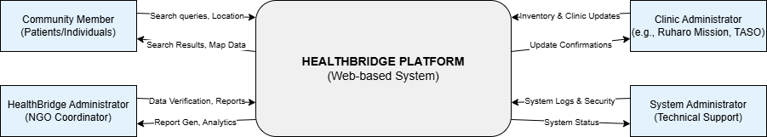

2. LEVEL 1 DATA FLOW DIAGRAM (DFD)
The Level 1 DFD decomposes the system into its major processes.
Process number | Process name | description
1 | User Management | Handles user registration, login, authentication, and profile management for all user types.
2 | Clinic Search & Discovery | Manages all search functionality, including location-based search, filtering, and result display.
3 | Clinic Information Management | Handles CRUD operations for clinic data, including updates, verification, and audit logging.
4 | Medicine Inventory Management | Manages medicine stock information for clinics, including updates and availability checks.
5 | Map & Geocoding Service | Interfaces with external mapping API to geocode addresses and display interactive maps
6 | Health Article Management | Manages the creation, storage, and display of health education articles.
7 | Reporting & Analytics | Generates reports on system usage, data quality, and clinic activity.
8 | System Administration | Handles backups, performance monitoring, and security management
Data Stores
Data store | description | description
D1 | User Database | Stores all user account information (Community Members, Clinic Admins, NGO Admins)
D2 | Clinic Database | Stores all clinic information (name, address, phone, hours, services, verification status)
D3 | Medicine Database | Stores medicine inventory data linked to specific clinics
D4 | Article Database | Stores health education articles and metadata
D5 | Audit Log Database | Stores logs of all changes made to clinic data for accountability
D6 | Search Log Database | Stores anonymized search queries for analytics
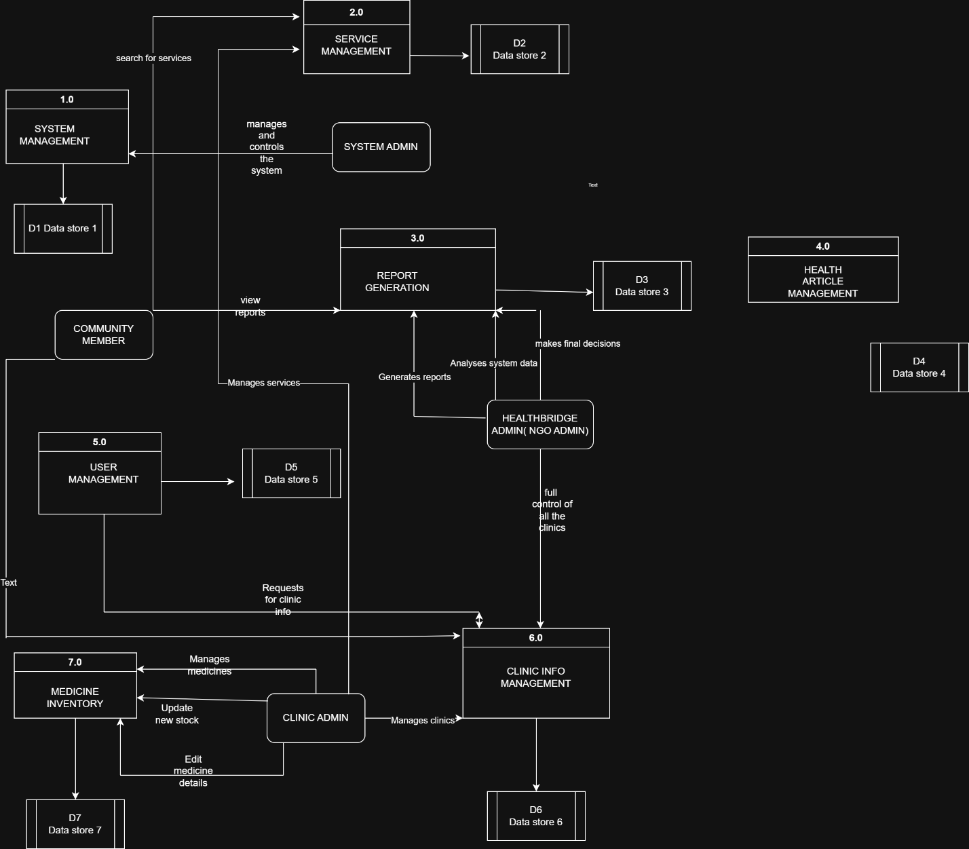

LEVEL 2 DATAFLOW DIAGRAM (DFD)
Process Selected: Report Generation by the Clinic Administrator
This is the core functionality for Community Members and deserves detailed breakdown.
Sub-Process | Process Name | Description
5.1 | Receive Report Request | Receives and validates report request from user (clinic or admin), checks for clinic updates
5.2 | Fetch Required Data | Retrieves data from multiple sources: clinic information, medical inventory, and system usage logs
5.3 | Validate and Clean Data | Validates data quality, removes errors, and compares current vs historical data
5.4 | Analyze Data | Performs analysis on cleaned data to identify trends, patterns, and insights
5.5 | Format and Generate Report Output | Formats analyzed data into the required report type and generates final report
5.6 | Decision Support Analysis | Provides actionable recommendations based on report findings
5.7 | Log Report Generation | Stores report metadata and generation logs for audit purposes

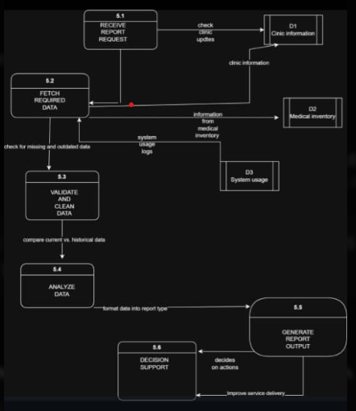

7. ACTIVITY DIAGRAM
Process Name: Clinic Update by Clinic Admin
Work flow steps
Clinic Administrator navigates to login page
- System displays login form
- Admin enters credentials
- System validates credentials
- System displays admin dashboard with clinic options
- Admin selects "Update Clinic Information"
- System retrieves current clinic data from database
- System displays pre-filled update form
- Admin modifies information (hours, phone, services, etc.)
- Admin submits changes
- System validates input (format, required fields)
- System checks for errors
- If errors found: System displays error messages, return to step 8
- If no errors: Proceed to step 13
- System updates database with new information
- System creates audit log entry (who changed what and when)
- System displays success confirmation to admin
- Process ends
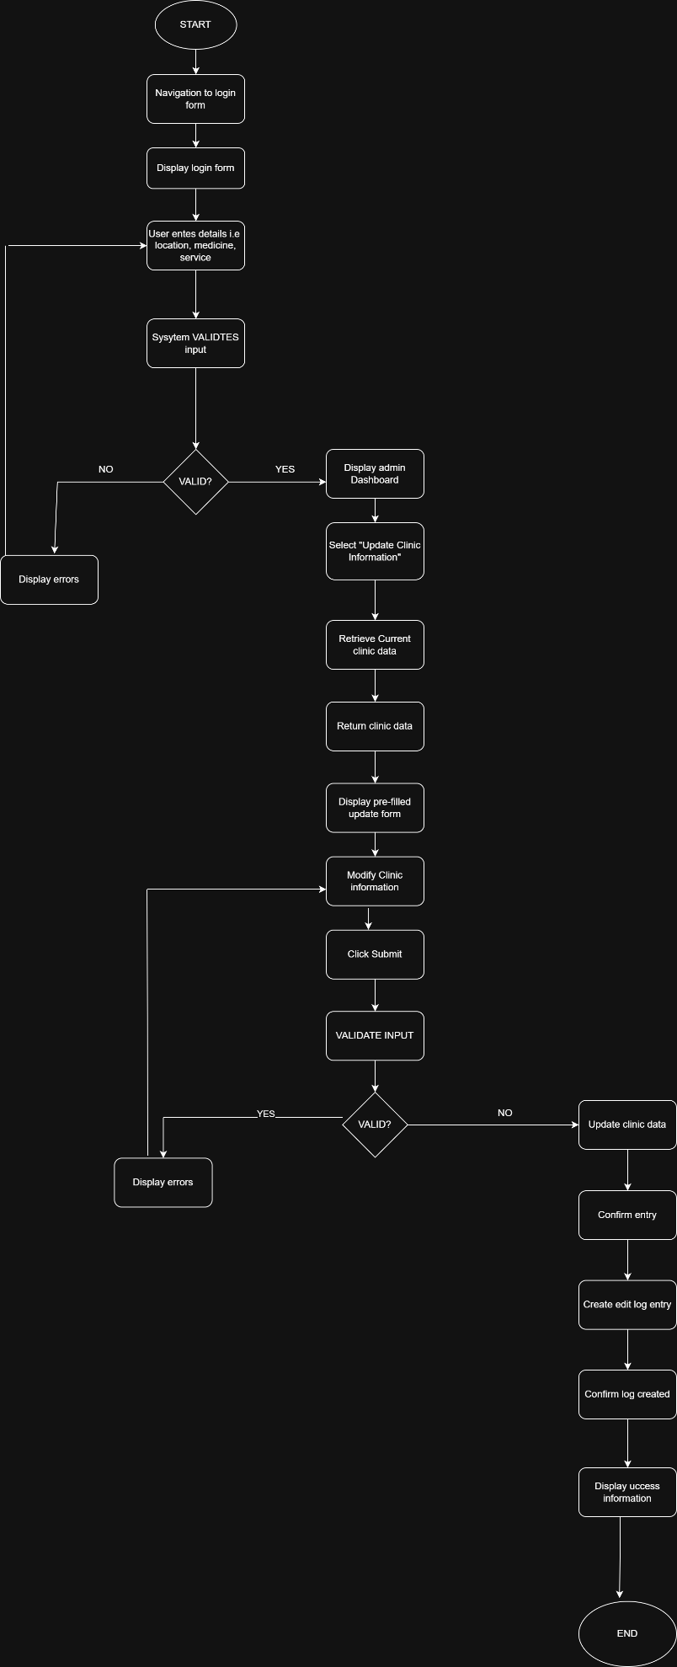

PART 2; DATA MODELS
These describe how information is organized escrioand related in the system
Entity | Description
User | Represents all system users (Community Members, Clinic Admins, NGO Admins, System Admins)
Clinic | Represents a healthcare facility (hospital, clinic, pharmacy) with all its details
Service | Represents a medical service offered by a clinic (Maternity, Dental, Pharmacy, etc.)
Medicine | Represents a specific medicine that clinics may stock
Clinic Medicine | Junction entity linking clinics to medicines with stock status
Clinic Service | Junction entity linking clinics to services offered
Health Article | Represents health education materials uploaded by admins
Audit Log | Records all changes made to clinic data for accountability
Search Log | Stores anonymized search queries for analytics
Verification | Tracks verification history for clinic data
IDENTIFICATION OF ATTRIBUTES
USERS
Attributes
- User id (INT, Primary Key) - Unique identifier for each user
- User name (VARCHAR(50)) - User's login name, must be unique
- password hash (VARCHAR(255)) - Encrypted password for security
- email (VARCHAR(100)) - User's email address
- phone (VARCHAR(20)) - Contact phone number
- full name (VARCHAR(100)) - User's complete name
- role (ENUM) - User type: community, clinic admin, ngo admin, system admin
- clinic id (INT, Foreign Key) - If clinic admin, which clinic they manage
- created at (DATETIME) - Account creation timestamp
- last login (DATETIME) - Last login timestamp is active (BOOLEAN) - Whether account is active (1=active, 0=inactive)
- created by (INT, Foreign Key) - Which admin created this user

Entity 2
CLINICS
Attributes:
- Clinic id (INT, Primary Key) - Unique identifier for each clinic name (VARCHAR(100)) - Clinic name
- address (TEXT) - Full physical address
- parish (VARCHAR(50)) - Parish or local area
- district (VARCHAR(50)) - District name
- latitude (DECIMAL(10,8)) - Geocoded latitude coordinate for mapping
- longitude (DECIMAL(11,8)) - Geocoded longitude coordinate for mapping
- phone (VARCHAR(20)) - Primary contact phone number
- email (VARCHAR(100)) - Contact email address
- opening hours (TEXT) - Days and hours of operation is verified (BOOLEAN) - Whether information is confirmed (1=verified, 0=pending)
- verified by (INT, Foreign Key) - Which admin verified this clinic
- verified date (DATETIME) - Date of last verification
- created at (DATETIME) - When record was created
- updated at (DATETIME) - Last update timestamp
- updated by (INT, Foreign Key) - Who last updated this record
- is active (BOOLEAN) - Whether clinic is still operational

Entity 3
MEDICINES

Attributes
- Medicine id (INT, Primary Key) - Unique identifier for each medicine
- generic name (VARCHAR(100)) - Scientific drug name
- brand name (VARCHAR(100)) - Common commercial name
- category (VARCHAR(50)) - Type of medicine (Antibiotic, Painkiller, etc.)
- description (TEXT) - Brief description of the medicine

Entity 4
CLINIC MEDICINE (Junction Table)
Attributes
- Clinic medicine id (INT, Primary Key) - Unique identifier for this link
- Clinic id (INT, Foreign Key) - Which clinic this record belongs to
- Medicine id (INT, Foreign Key) - Which medicine this record is about
- Stock status (ENUM) - Current availability: In Stock, Low Stock, Out of Stock
- Updated at (DATETIME) - Last stock update timestamp

Entity 5
SERVICES
Attributes
- Service id (INT, Primary Key) - Unique identifier for each service
- Service name (VARCHAR(50)) - Name of service (Maternity, Dental, Pharmacy, etc.)
- description (TEXT) - Brief explanation of the service

Entity 6
CLINIC_SERVICE (Junction Table)
Attributes
- Clinic service id (INT, Primary Key) - Unique identifier for this link
- Clinic id (INT, Foreign Key) - Which clinic offers this service
- Service id (INT, Foreign Key) - Which service is offered is available (BOOLEAN) - Whether service is currently available

Entity 7
HEALTH ARTICLES
Attributes
- Article id (INT, Primary Key) - Unique identifier for each article
- title (VARCHAR(200)) - Article headline
- content (TEXT) - Full article text
- category (VARCHAR(50)) - Topic area (Nutrition, First Aid, etc.)
- author id (INT, Foreign Key) - Which admin wrote this article
- created_at (DATETIME) - Publication date
- updated_at (DATETIME) - Last edit date
- view_count (INT) - Number of times article has been read
- is_published (BOOLEAN) - Whether article is visible to public

Entity 8
AUDIT LOGS
Attributes
- log_id (INT, Primary Key) - Unique identifier for each log entry
- user_id (INT, Foreign Key) - Which user performed the action
- action (VARCHAR(50)) - Type of action (UPDATE, DELETE, VERIFY, etc.)
- entity_type (VARCHAR(50)) - Type of record changed (Clinic, Medicine, User)
- entity_id (INT) - Which specific record was changed
- old_values (TEXT) - JSON of data before change
- new_values (TEXT) - JSON of data after change
- timestamp (DATETIME) - When action occurred
- ip_address (VARCHAR(45)) - User's IP address

Entity 9
SEARCH_LOGS
Attributes
- search_id (INT, Primary Key) - Unique identifier for each search
- search_query (VARCHAR(255)) - What the user typed
- filters (TEXT) - JSON of applied filters
- result_count (INT) - Number of clinics found
- timestamp (DATETIME) - When search occurred
- user_id (INT, Foreign Key) - Which user searched (NULL if anonymous)
- session_id (VARCHAR(100)) - Temporary ID for anonymous tracking
- updated_by (INT, Foreign Key) - Who updated the stock information
- notes (TEXT) - Additional comments about this medicine

IDENTIFYING RELATIONSHIPS
ENTITY 1 | RELATIONSHIP | ENTITY 2
users | manages | clinics
clinics | has | Clinic medicine
user | generates | Search logs
Services | Offered by | Clinic service
Clinic service | Belongs to | clinic
medicine | Appears in | Clinic medicine
User | Belongs to | clinic

ENTITY RELATIONSHIP DIAGRAM FOR HEALTHBRIDGE
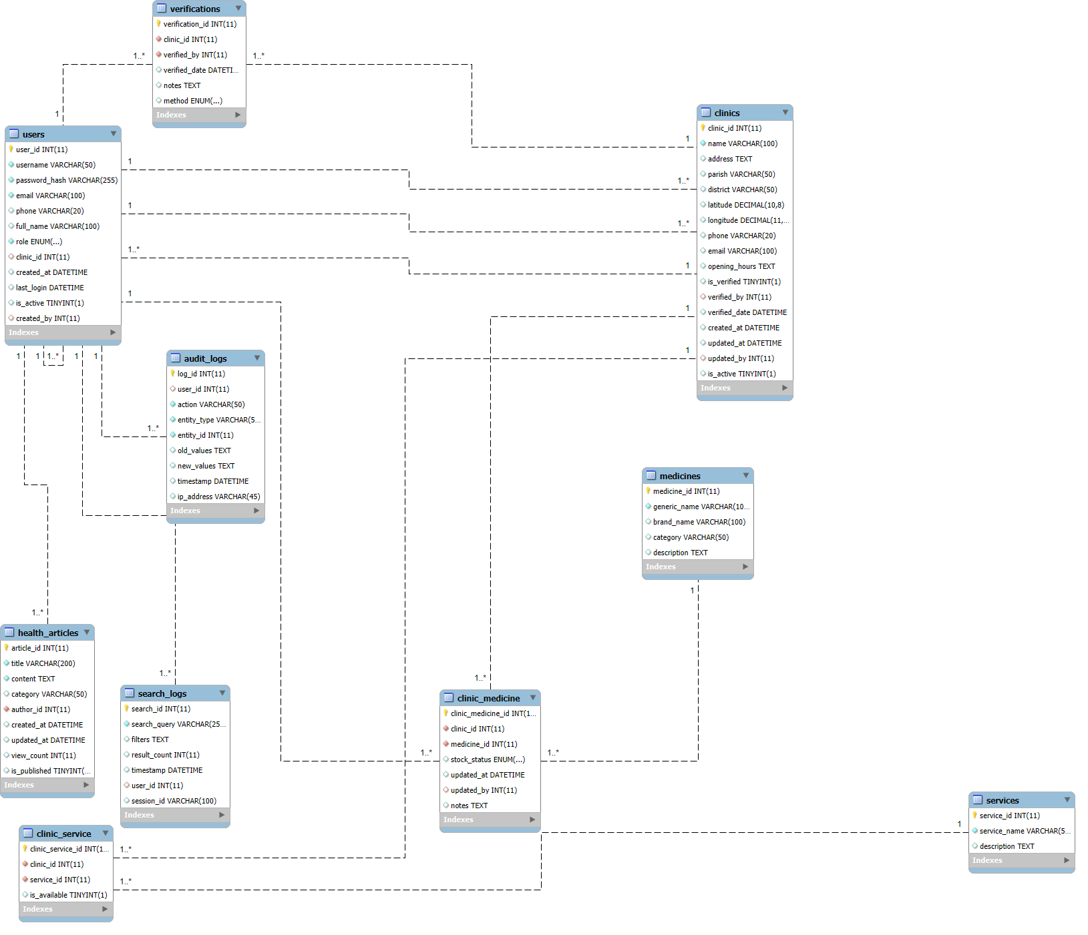
PART 3. USER INTERFACE AND INTERACTION MODELS
USERS OF HEALTHBRIDGE SYSTEM
ACTOR | DESCRIPTION
Community member | A patient or community member seeking health services. They are the primary end-users of the system.
Clinic administrator | Staff member at a specific clinic responsible for keeping that clinic's data accurate and up-to-date.
HealthBridge Administrator | Coordinator at the NGO who oversees the entire system, verifies data quality, and manages content
System administrator | Technical person responsible for system maintenance, backups, security, and performance
Third party mapping API | External system actor that provides geocoding and map visualization services.
USE CASES OF THE HEALTHBRIDGE
ACTOR | USE CASE
Community member/patient | Register Account (optional), Search for Clinics, Filter Search by Service Type, Filter Search by Medicine Availability, View Clinic DetailsView Clinic on Map, Read Health Articles  Contact Clinic (via phone link), Provide Feedback
Clinic administrator | Login to System  View Dashboard  Update Clinic Information  Manage Medicine Inventory, ViewClinic Profile (public view),  Request Verification
Healthbridge administrator | Login to System, View Admin Dashboard, Add New Clinic, Edit Clinic Details, Delete Clinic  Verify Clinic Data, Manage Medicine List (global), Manage Service List, Generate Reports, Upload Health Articles, Edit/Delete Health Articles, Manage User Accounts View Audit Logs
System administrator | Login to System, Backup System Data, Monitor System Performance, Manage Security Settings, View System Logs
All actors | Logout of System

USE CASE DIAGRAM
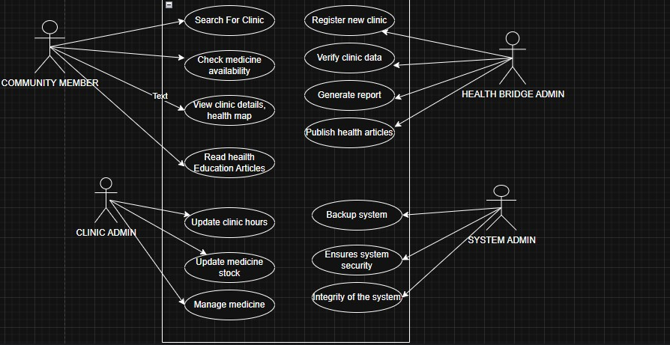

SEQUENCE DIAGRAM
Use case selected: Clinic Administrator Updates Medicine Inventory
Objects Involved
- Clinic Admin (Actor)
- Login Interface (UI)
- Authentication Controller (System)
- Dashboard Interface (UI)
- Medicine Controller (System)
- Medicine Database (Data Store)
- Audit Log Database (Data Store

Interaction Steps
- Admin enters username and password
- System validates credentials
- System displays admin dashboard
- Admin clicks "Manage Medicine Inventory"
- System retrieves current medicine list for that clinic
- System displays medicine inventory form
- Admin updates stock status for medicines
- Admin submits changes
- System validates input
- System updates Medicine Database
- System creates audit log entry
- System confirms success to admin

Sequence diagram

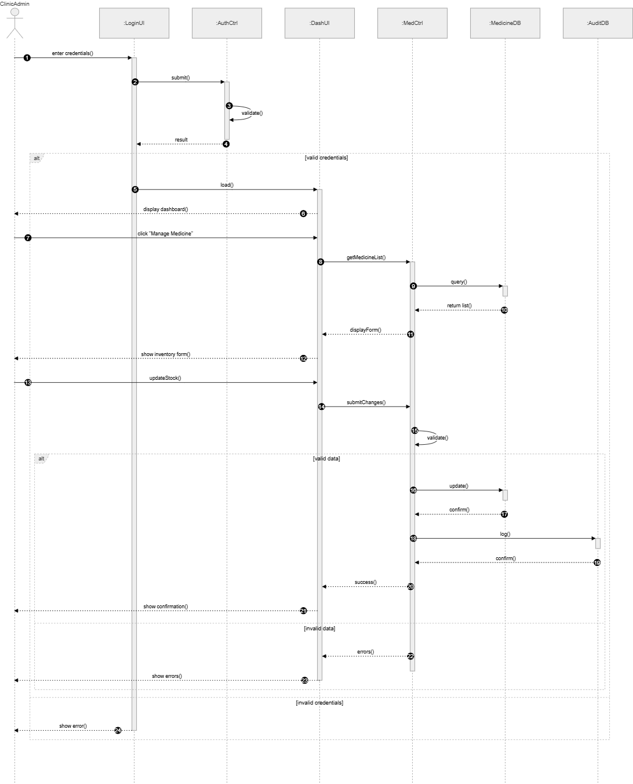

USER INTERFACE WIREFRAMES
Key Screens on the healthbridge system
Screen | Purpose
Homepage | Welcome page with search bar and featured content
Search Results | Displays clinics matching search criteria (map + list)
Clinic Details | Shows detailed information about a specific clinic
Medicine Check | Interface for checking medicine availability
Health Articles | List of health education articles
Article Reader | Full article display
Login Page | User authentication for admins
Admin Dashboard | Overview panel for administrators
Clinic Management | Form for adding/editing clinic information
Medicine Inventory | Interface for updating medicine stock
WIREFRAMES
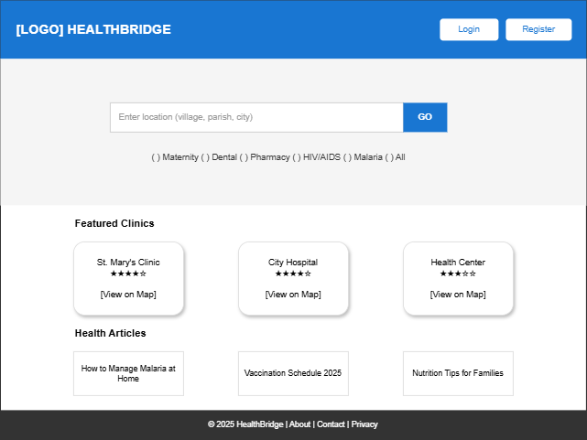

SCREEN NAVIGATION DIAGRAM
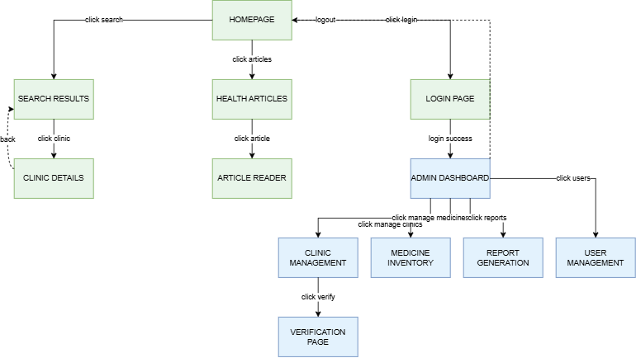

FINAL REMARKS: GROUP REFLECTION
The Use Case Diagram helped our group understand the HealthBridge system best.
Reason; It clearly distinguished what is inside the system (use cases) versus outside (actors). This helped us define the scope of our project.

The Level 2 Data Flow Diagram (DFD) was the most difficult model to develop for HealthBridge.
Reason; Taking one process (Clinic Search & Discovery) and breaking it into 7 sub-processes (2.1 to 2.7) required careful thinking about every step a user takes and every system action.

System modeling significantly improved our HealthBridge project design in the following ways:
Clear requirements understanding; Modeling forced us to think through every feature before writing code for example the Use Case Diagram helped us identify 30+ specific functions the system must perform.
Identified missing features; Visualizing the system revealed gaps we hadn't considered for example the Activity Diagram showed we needed an audit log step after updating clinic data. We had forgotten this, but the model highlighted it.

